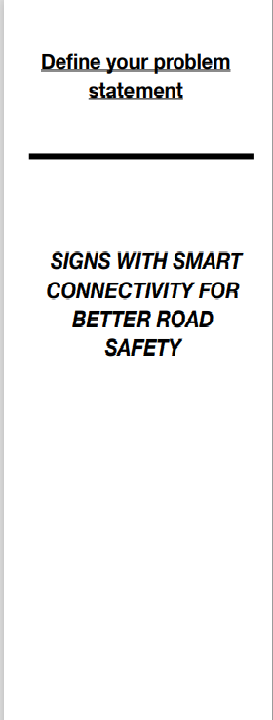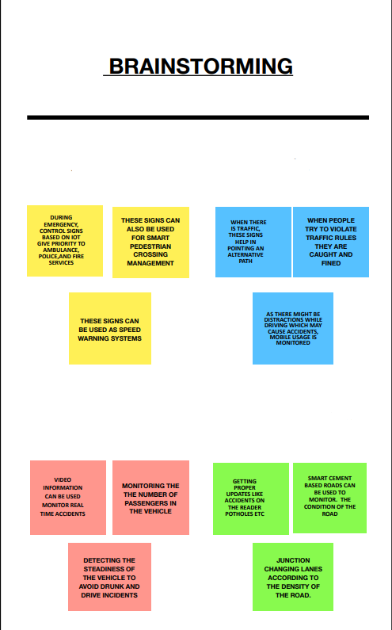

**Team ID**: PNT2022TMID07524

**Project Title:** Real-Time River Water Quality Monitoring and Control System

Disposal of Solid and chemical wastes into the river water resulting in contamination of water and also disturbing the life existing in water

**Water pH, turbidity, and algorithm encryption and decryption data**

**Bio treatment for contaminated water**

**Manual checking of water contamination by paper report**

**Hydroponics and aqua phonics technology for pH indicator**

**Wireless water a parameter’s data based on a collecting network**

**Building app and turbidity the level of using river water to measure pH**

**Statistical, temperature data values pH storage and recording procedure**

**Using two nri cameras and image processing as a measurement device**

**Arduino with water based sensors**

**Prefixed numbers in Arduino track the river’s quality indicators**

**Determining the pH, temperature and turbidity threshold values**

**Sensors for temperature, turbidity and pH coupled to an Ardunio**

**IDEATION**

IDEAS

Arduino and sensor based water parameter (pH,temperature) monitoring

Automatic removal of waste present on water

Alerting the user based on the analysis

Analysis of pH temperature, Turbidity values

WEB APPLICATION USING NODERED

USER INTERFACE

IOT DEVICE